**COAL LAB 8**

**Task 1:**

**Output:**

**Task 2:**

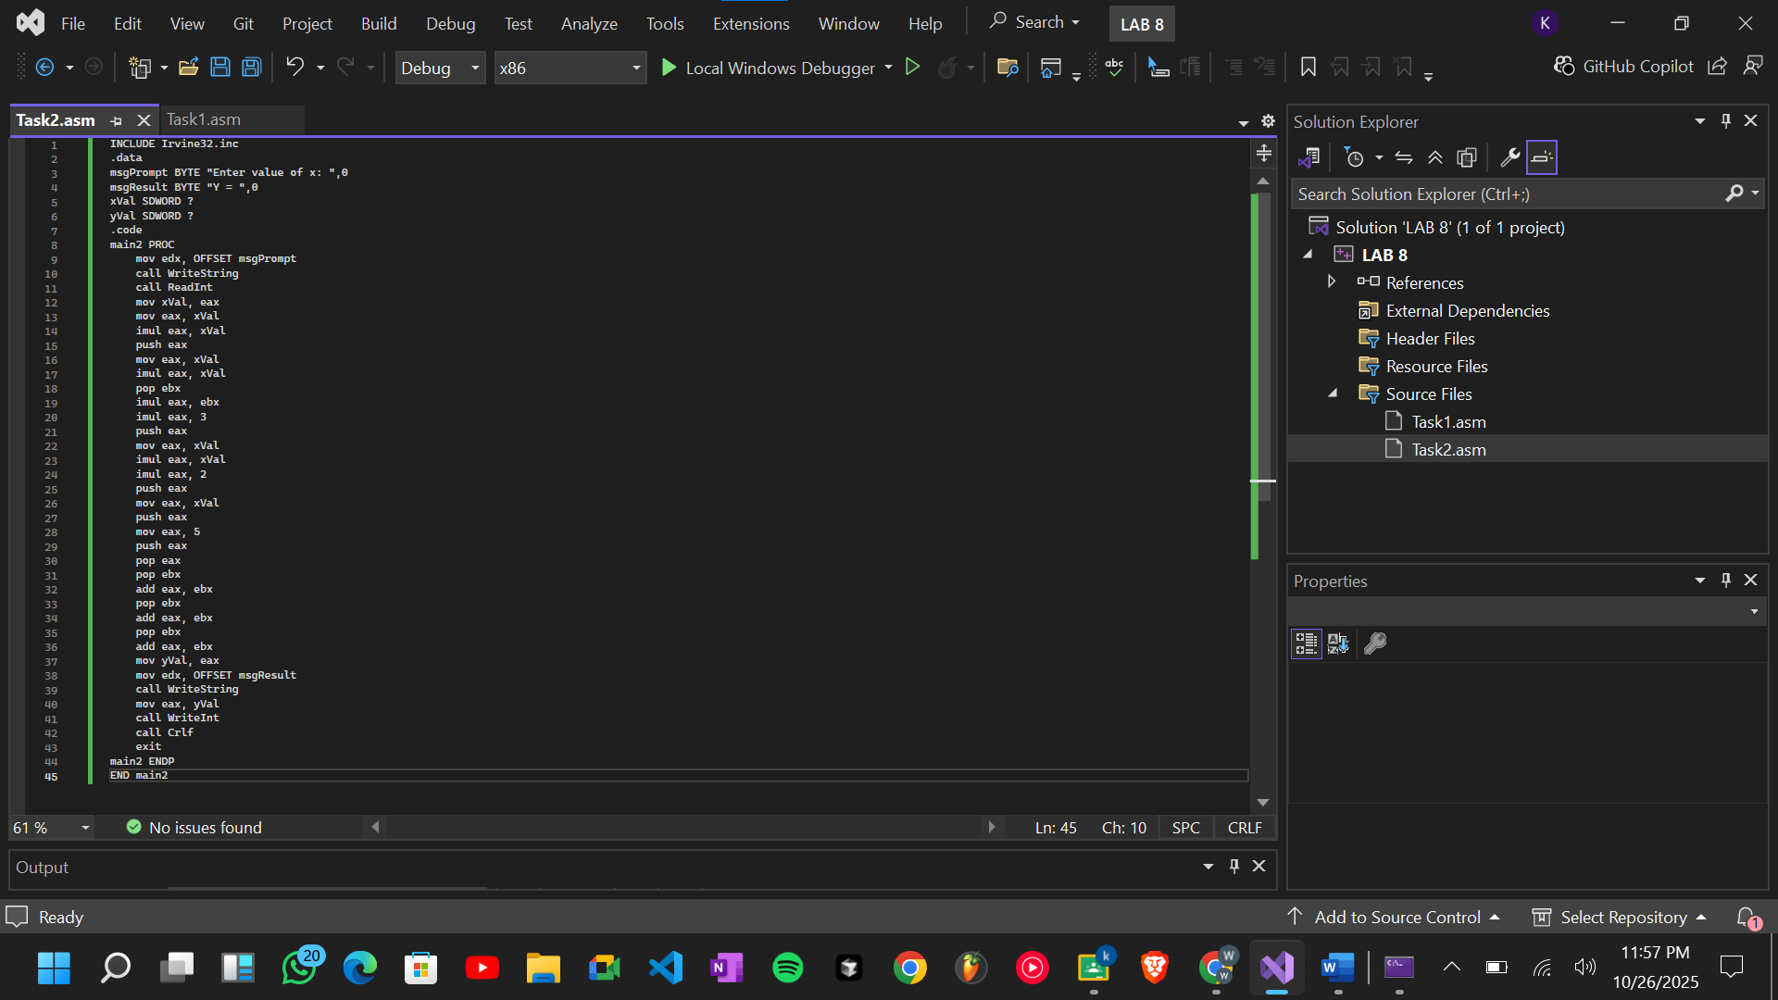

**Output:**



**Task 3:**

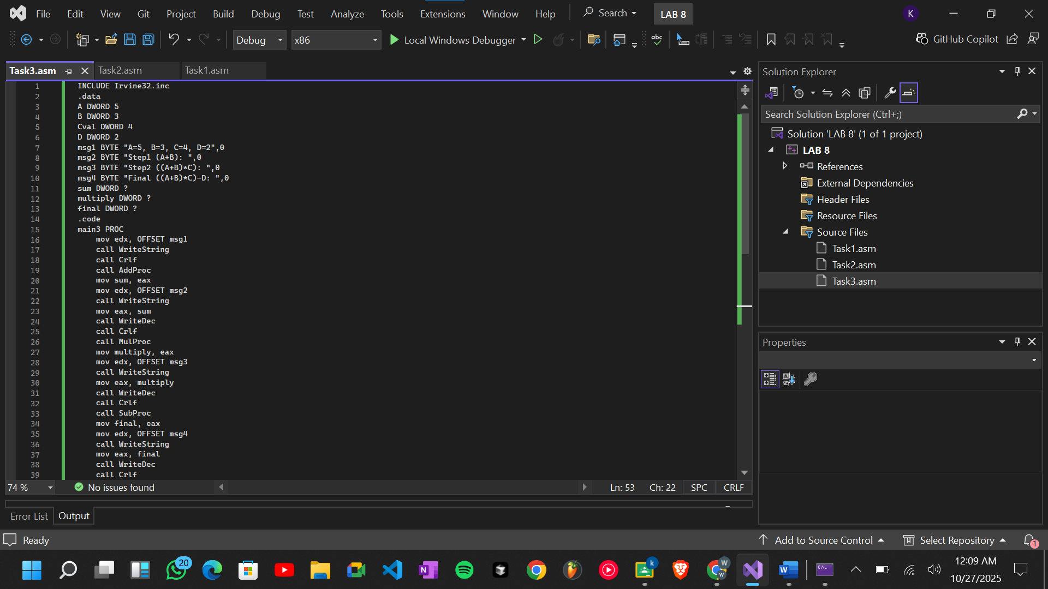

**Output:**

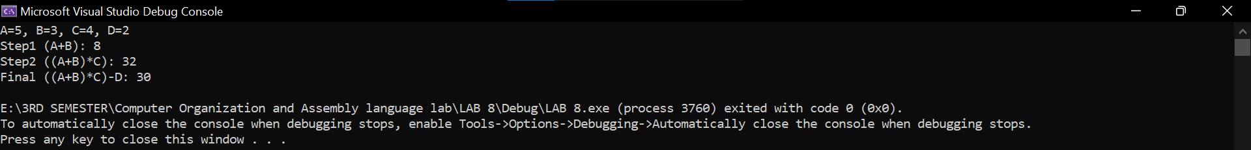

**Task 4:**

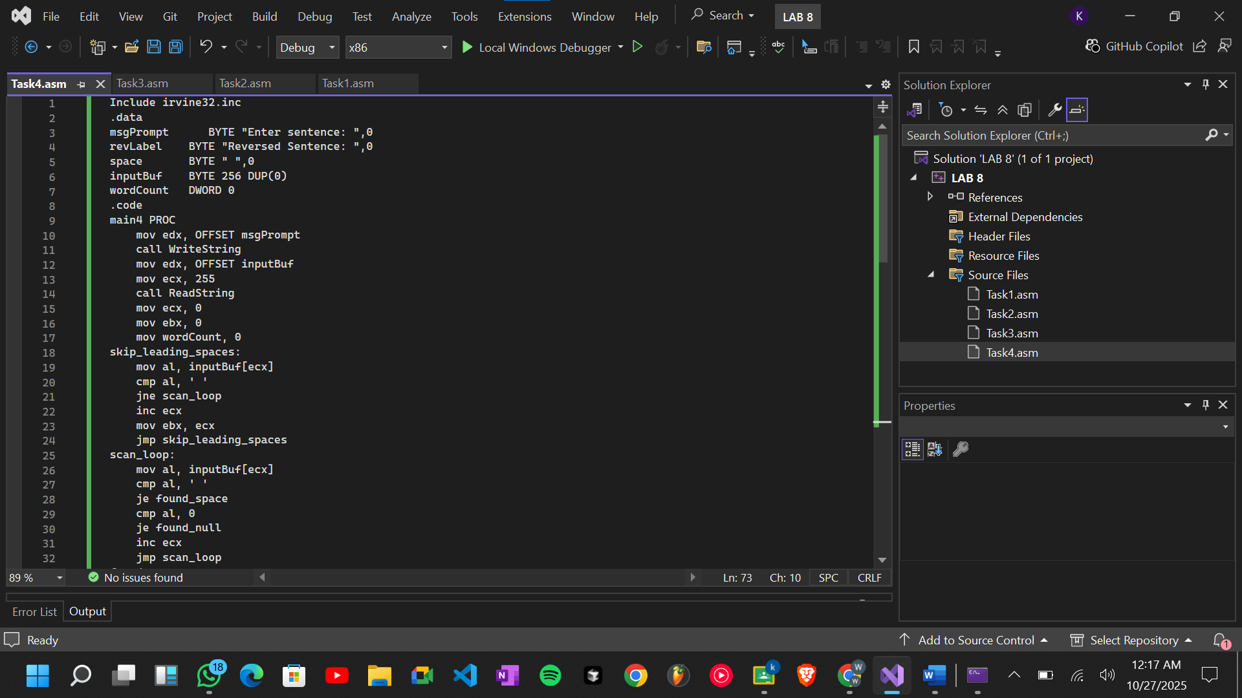

**Output:**



**Task 5:**

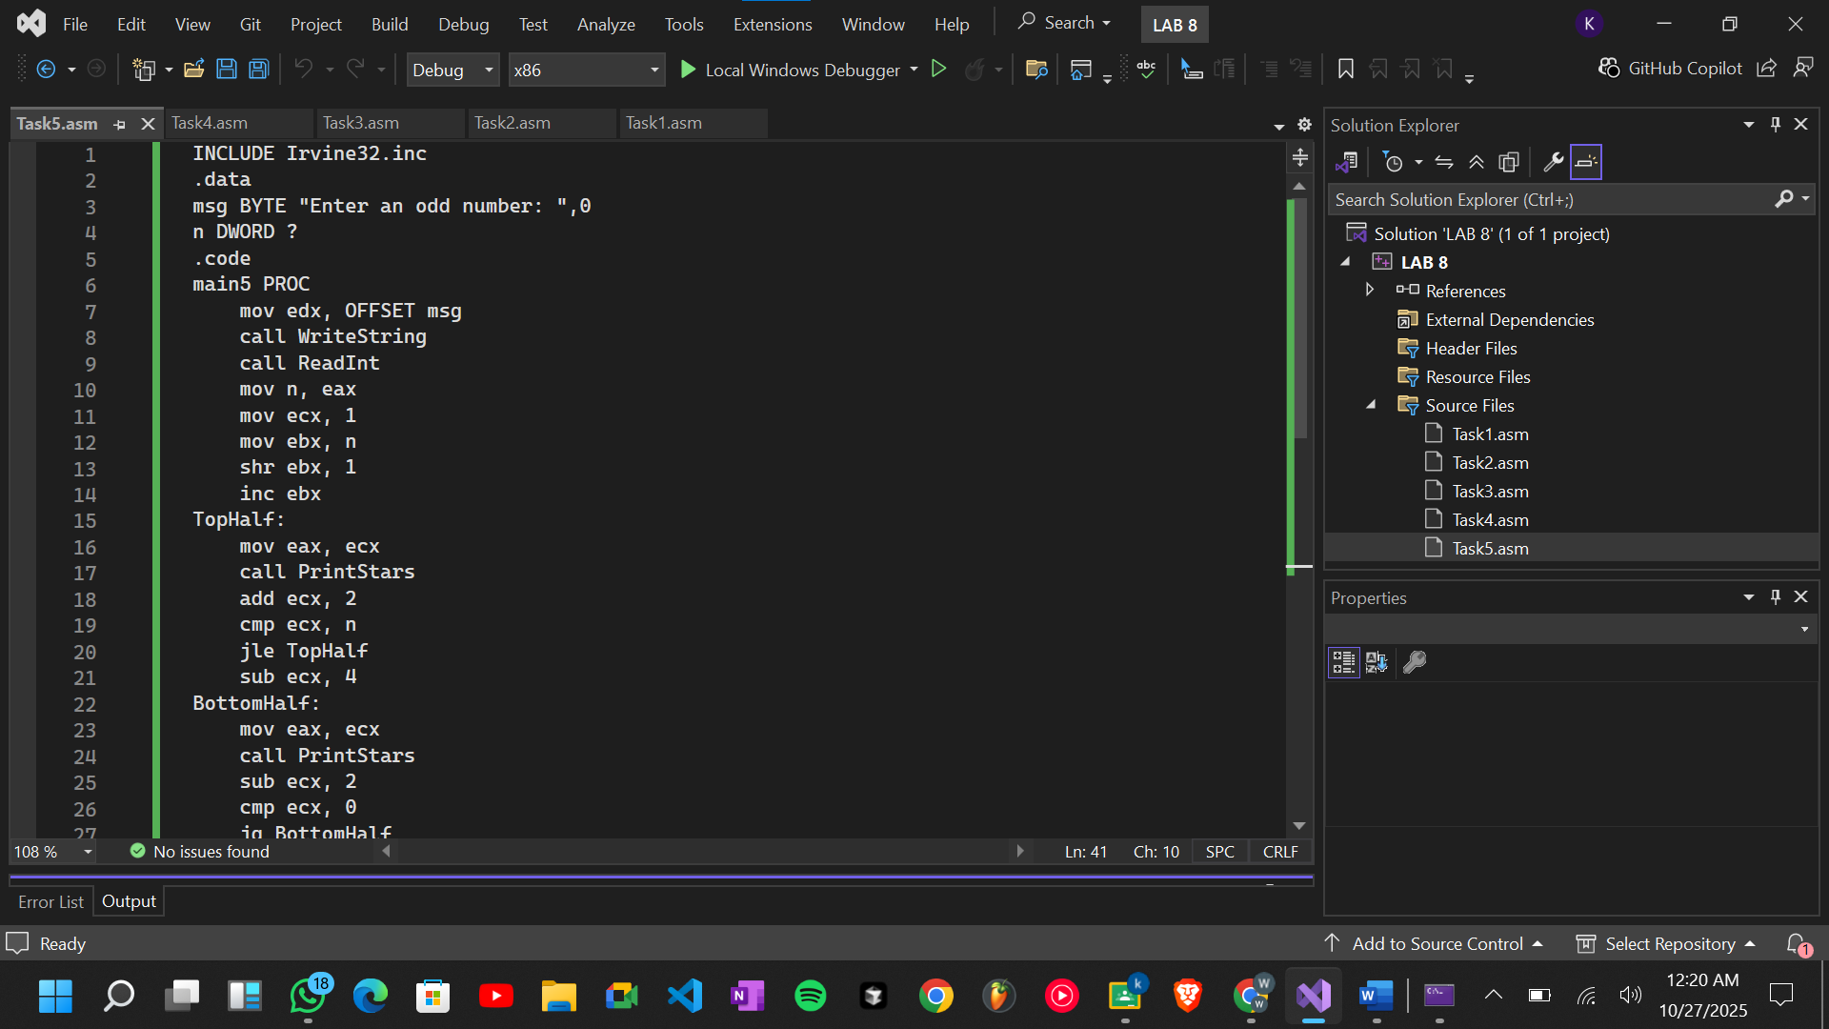

**Output:**

